# Relations before Normalizing

1. Order+Customer+Food(OrderNo, CustID, Name, Address, Email, PhoneNo, Quantity, FoodID, Food_Name, Description, Price, Quantity, Category_ID)
2. Category(CategoryID, Title, Featured, Active)
3. Admin (AdminID, Admin_Password, Employee_ID,First_Name,Last_Name,Gender, City, Salary)
4. DeliveryBoy (DBoyID, Employee_ID,First_Name,Last_Name,Gender, City, Salary)
5. Chef (ChefID, Employee_ID, First_Name, Last_Name, Gender, City, Salary)
6. Manager (Manager_ID, EmployeeID, First_Name, Last_Name, Gender, City, Salary

# Normalization

## Order+Customer+Food

### Functional Dependencies:

1. {OrderNo, CustID} -> {DBoyID, FoodID}
2. CustID -> {Name, Address, Email, PhoneNo}
3. FoodID -> FoodName, Description, Price, AdminID, Quantity, CatagoryID

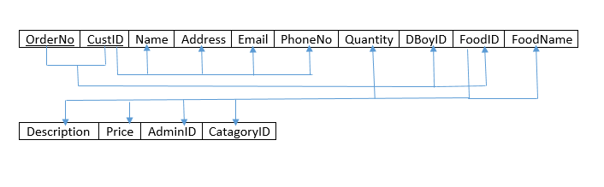

### Finding Candidate Keys

{OrderNo,CustID}*={OrderNo,CustID,Name,Address,Email,PhoneNo,Quantity,DBoyID,FoodID,FoodName,Description,Price,AdminID} **Candidate Key**

P.K (OrderNo, CustID) N.P.K (All except OrderNo)

### 1-NF:

The Relation is already in 1-NF.

### 2-NF:

FD1 is violating the condition hence decomposing table into.

Order+Food(OrderNo,CustID(FK),Quantity,DBoyID,FoodID,FoodName,Description,Price,AdminID(FK), CatagoryID(FK))

Customer (CustID, Name, Address, Email, PhoneNo)

### 3-NF:

FD3 is violating the condition hence decomposing the tables into:

Order (OrderNo, CustID, DBoyID, FoodID)

Food (FoodID, Food_Name, Description, Price, Admin_ID, Quantity, CatagoryID)

Customer (CustID, Name, Address, Email, PhoneNo)

### BCNF:

Already in BCNF

### Decomposed Tables

Order

|  |  |  |  |
| --- | --- | --- | --- |
| OrderNo | CustID(FK) | DBoyID(FK) | FoodID(FK) |

Food

|  |  |  |  |  |  |  |
| --- | --- | --- | --- | --- | --- | --- |
| FoodID | FoodName | Description | Price | Admin_ID(FK) | Quantity | CatagoryID |

Customer

|  |  |  |  |  |
| --- | --- | --- | --- | --- |
| CustID | Name | Address | Email | PhoneNo |

## Category

### Functional Dependencies:

1. CategoryID -> Title, Featured, Active

### Finding Candidate Keys

CategoryID*= {CategoryID, Title, Featured, Active} **Candidate Key**

P.K (CatagoryID) N.P.K (All except OrderNo)

### 1-NF:

The Relation is already in 1-NF.

### 2-NF:

The Relation is already in 2-NF.

### 3-NF:

The Relation is already in 3-NF.

### BCNF:

The Relation is already in BCNF

Category

|  |  |  |  |
| --- | --- | --- | --- |
| CategoryID | Title | Featured | Active |

## Admin

### Functional Dependencies

1. AdminID -> EmployeeID
2. EmployeeID -> {First_Name,Last_Name,Gender,City,Salary}

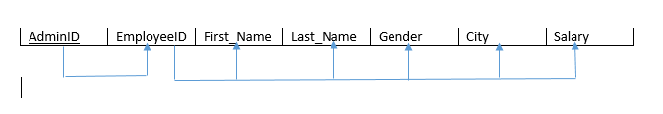

### Finding Candidate keys

AdminID* = {AdminID, Employee_ID, First_Name, Last_Name, Gender, City, Salary} **Candidate Key**

**P.K (**AdminID**) N.P.K (**All except AdminID**)**

### 1-NF

The Relation is already in 1-NF

### 2-NF

The relation is already in 2-NF

### 3-NF

FD2 is violating the condition hence decomposing into:

Admin (AdminID, Employee_ID)

Employee (Employee_ID, First_Name, Last_Name, Gender, Salary, City)

### BCNF

The relation is already in BCNF

### Decomposed Tables:

Admin

|  |  |
| --- | --- |
| AdminID | Employee_ID |

Employee

|  |  |  |  |  |  |
| --- | --- | --- | --- | --- | --- |
| Employee_ID | First_Name | Last_Name | Gender | Salary | City |

## Delivery_Boy

### Functional Dependencies

1. DBoyID -> EmployeeID
2. EmployeeID -> {First_Name,Last_Name,Gender,City,Salary}

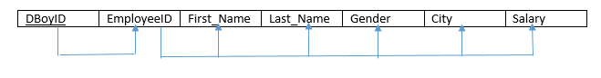

### Finding Candidate keys

DBoyID* = {DBoyID, Employee_ID, First_Name, Last_Name, Gender, City, Salary} **Candidate Key**

**P.K (**DBoyID**) N.P.K (**All except DBoyID**)**

### 1-NF

The Relation is already in 1-NF

### 2-NF

The relation is already in 2-NF

### 3-NF

FD2 is violating the condition hence decomposing into:

Delivery Boy (DBoyID, Employee_ID)

Employee (Employee_ID, First_Name, Last_Name, Gender, Salary, City)

### BCNF

The relation is already in BCNF

### Decomposed Tables:

Delivery_Boy

|  |  |
| --- | --- |
| DBoyID | Employee_ID |

Employee Table was already created during Normalization of Admin.

## Chef

### Functional Dependencies

1. Chef_ID -> EmployeeID
2. EmployeeID -> {First_Name,Last_Name,Gender,City,Salary}

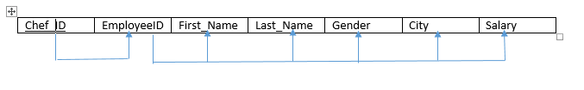

### Finding Candidate keys

Chef_ID* = {Chef_ID, Employee_ID, First_Name, Last_Name, Gender, City, Salary} **Candidate Key**

**P.K (**Chef_ID**) N.P.K (**All except Chef_ID**)**

### 1-NF

The Relation is already in 1-NF

### 2-NF

The relation is already in 2-NF

### 3-NF

FD2 is violating the condition hence decomposing into:

Chef (Chef_ID, Employee_ID)

Employee (Employee_ID, First_Name, Last_Name, Gender, Salary, City)

### BCNF

The relation is already in BCNF

### Decomposed Tables:

Chef

|  |  |
| --- | --- |
| Chef ID | Employee_ID |

Employee Table was already created during Normalization of Admin.

## Manager

### Functional Dependencies

1. Manager_ID -> EmployeeID
2. EmployeeID -> {First_Name,Last_Name,Gender,City,Salary}

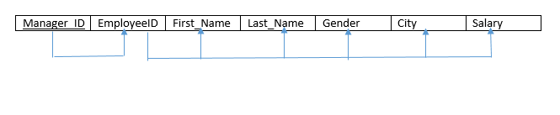

### Finding Candidate keys

Manager_ID* = {Manager_ID, Employee_ID, First_Name, Last_Name, Gender, City, Salary} **Candidate Key**

**P.K (**Chef_ID**) N.P.K (**All except Chef_ID**)**

### 1-NF

The Relation is already in 1-NF

### 2-NF

The relation is already in 2-NF

### 3-NF

FD2 is violating the condition hence decomposing into:

Chef (Chef_ID, Employee_ID)

Employee (Employee_ID, First_Name, Last_Name, Gender, Salary, City)

### BCNF

The relation is already in BCNF

### Decomposed Tables:

Manager

|  |  |
| --- | --- |
| Manager ID | Employee_ID |

Employee Table was already created during Normalization of Admin.

# After Normalization

Order

|  |  |  |  |
| --- | --- | --- | --- |
| OrderNo | CustID(FK) | DBoyID(FK) | FoodID(FK) |

Food

|  |  |  |  |  |  |  |
| --- | --- | --- | --- | --- | --- | --- |
| FoodID | FoodName | Description | Price | Admin_ID(FK) | Quantity | CatagoryID |

Customer

|  |  |  |  |  |
| --- | --- | --- | --- | --- |
| CustID | Name | Address | Email | PhoneNo |

Category

|  |  |  |  |
| --- | --- | --- | --- |
| CategoryID | Title | Featured | Active |

Admin

|  |  |
| --- | --- |
| AdminID | Employee_ID |

Employee

|  |  |  |  |  |  |
| --- | --- | --- | --- | --- | --- |
| Employee_ID | First_Name | Last_Name | Gender | Salary | City |

Delivery_Boy

|  |  |
| --- | --- |
| DBoyID | Employee_ID |

Chef

|  |  |
| --- | --- |
| Chef ID | Employee_ID |

Manager

|  |  |
| --- | --- |
| Manager ID | Employee_ID |

ER DIAGRAM:  
